RehabTrack App User Manual

16/10/2023

Authors:

Kristian Whittaker

Sean Fowers

Welcome to the RehabTrack User Manual. This guide will help you understand and navigate the RehabTrack mobile application. Please follow the instructions below to make the most of this app.

Contents

Installation Guide 3

Initial Setup 6

Adding Exercises to a List of Exercises 6

Adding a Patient 7

Adding a Session 8

Screen Information 11

Home Screen 11

New Session Screen 12

Repetitions Screen 13

Settings Screen 14

Patient Records Screen 15

Patient Screen 16

Session History Screen 17

Session Screen 18

Data Export Page 19

Graphing Screen 20

# Installation Guide

1. **Step One**  
   Have a working Android Mobile Device. (Tablets may be functional but have not been tested).
2. **Step Two**Download the APK. The file is called RehabTrack v1.0.apk, download this to your android mobile device.
3. 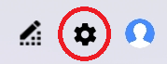**Step Three**Open the Settings Menu on your android mobile device.
4. 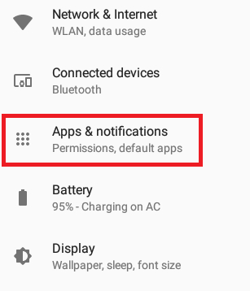**Step Four**Navigate to Apps & Notifications.
5. **A screenshot of a phone

   Description automatically generatedStep Five**  
   Navigate to Special App Access.
6. 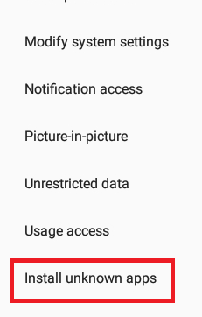**Step Six**Navigate to “Install Unknown Apps”.
7. 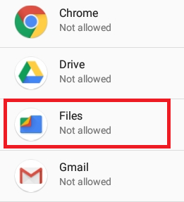**Step Seven**Navigate to files or another applicable app (Such as the browser you downloaded the file from).
8. 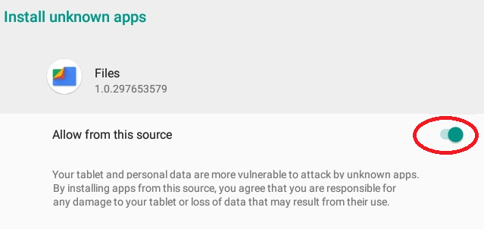**Step Eight**  
   Tap “Allow from this source”
9. **Step Nine**  
   Find your downloaded APK file in your android files (or tap it if it’s listed in your notifications) and open it / tap it.
10. 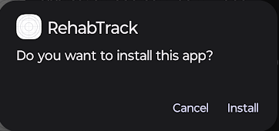 **Step Ten**Install the application.  
    If a warning screen appears, tap the text “Install Anyway” to then find the install button.
11. **Step Eleven**You’re done! Open the app.

# Initial Setup

### Adding Exercises to a List of Exercises

Navigate to the Settings Screen.

Find the “Add Exercise” button. Type in an exercise name and press the “Add Exercise” button.  
This will add the new exercise to the exercise list (displayed beneath this) which makes the exercise available for selection when editing exercises.

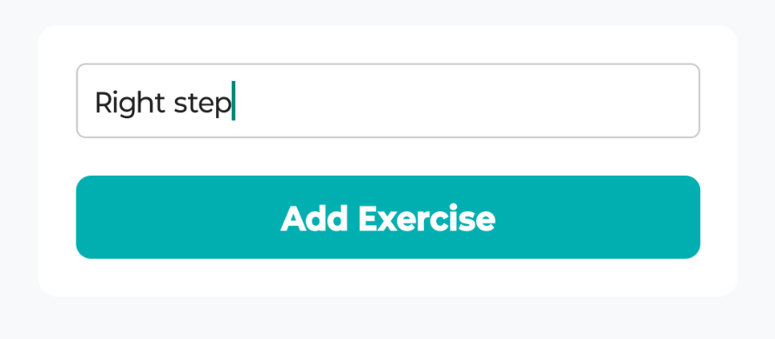

### Adding a Patient

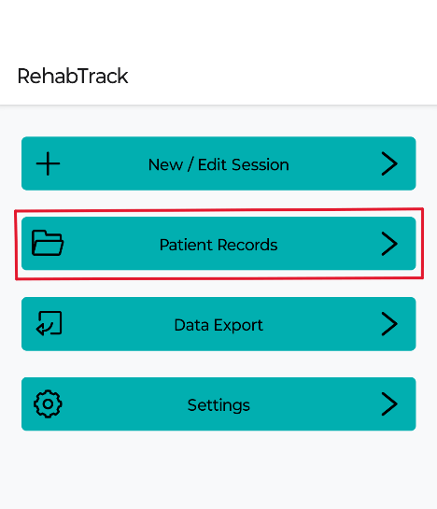Navigate to the Patient Records Screen.

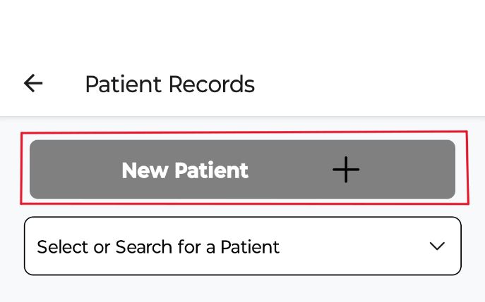

Find the “New Patient” Button and tap it.

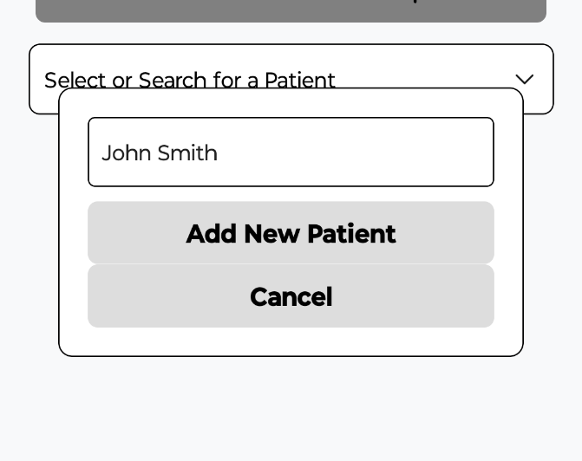Type a name in and press the “Add New Patient” button. This adds a patient to our patient records and makes it accessible throughout the app.

### Adding a Session

Navigate to the New Session Screen.

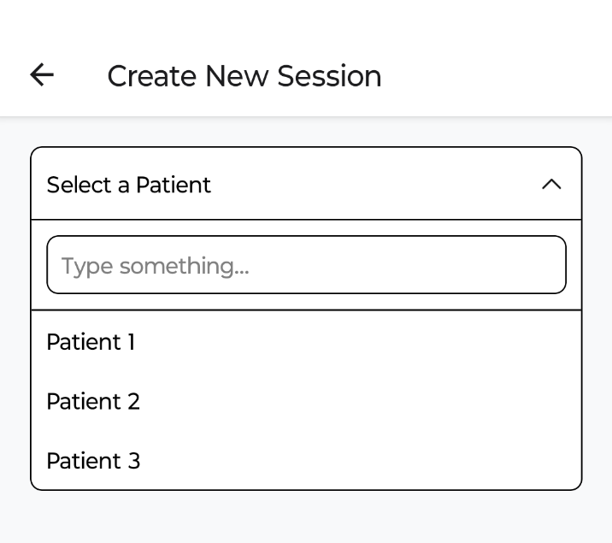

Find the Select a Patient Dropdown. Select your patient.

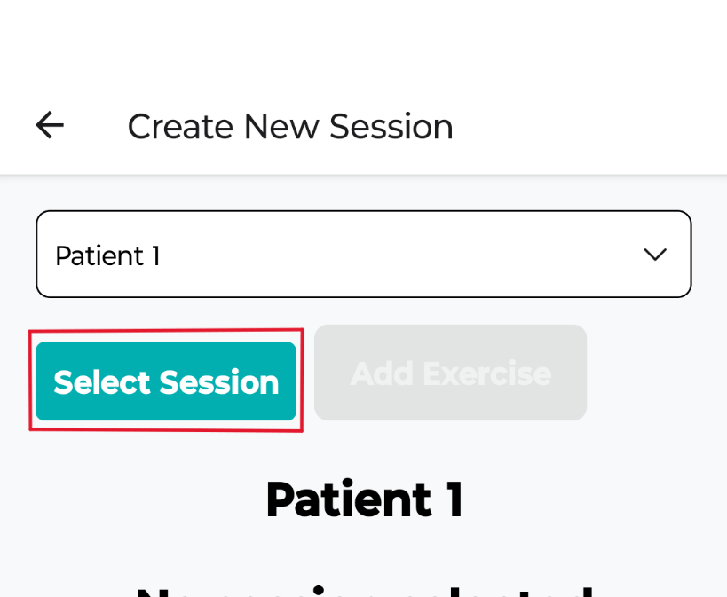With your patient selected, find the “Select Session” button, and tap it.

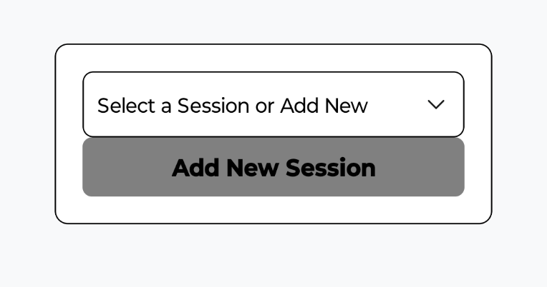Select a session from the dropdown list or tap the “Add New Session” button to add a new session.

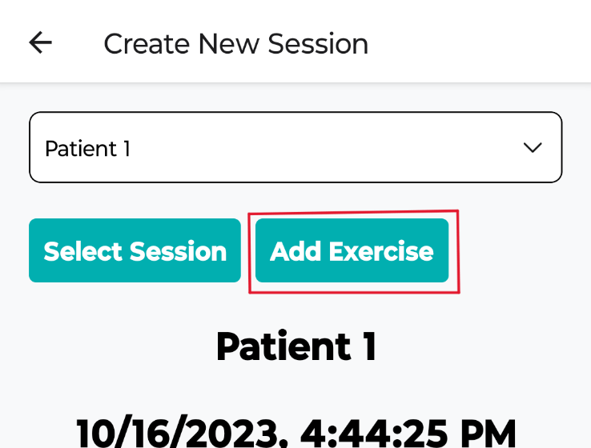With a Session selected find the “Add Exercise” button. This will add a new exercise to your session.

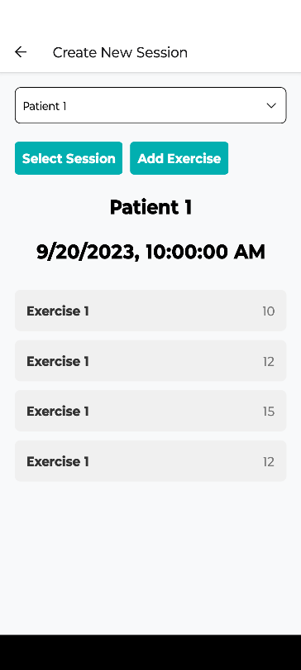Editing Exercises.

On the New Session screen, having selected a patient and a session, you’ll be given a list of exercises below. Add an exercise or tap an existing one to bring up the Repetitions Screen.

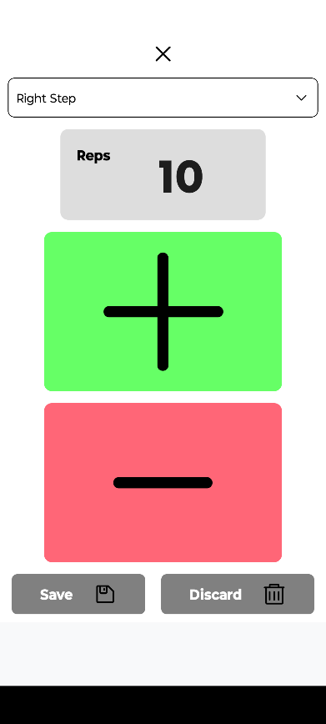On the Repetitions Screen you’ll find a dropdown list of existing exercises (See “adding an exercise to list of exercise” on how to add items to this list).   
  
Select an item from the list to set that exercise to the currently selected one.  
  
To change the repetition values, you can tap the + or – buttons to quickly add or take from the value. Alternatively you can tap the number of reps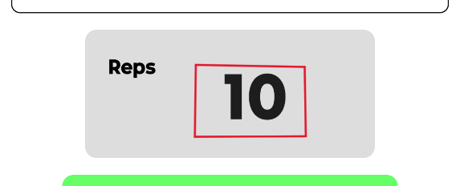

To manually type in a number.

To save your changes, press the “Save” button at the bottom of the screen. To cancel your changes, press the “Discard” button. (This will not delete the exercise, it will return to the New Session Screen without your changes).

# Screen Information

## Home Screen

The Home Screen is the starting point for your RehabTrack application journey. Here you will find essential buttons and information. Navigate to the New Session Screen, Patient Records Screen, Data Export Screen, or the Settings Screen from this page.

Buttons:

* **New / Edit Session Button: Navigate to the New Session screen.**
* **Patient Records Button: Navigate to the Patient Records screen.**
* **Data Export Button: Navigate to the Data Export screen.**
* **Settings Button: Navigate to the Settings screen.**

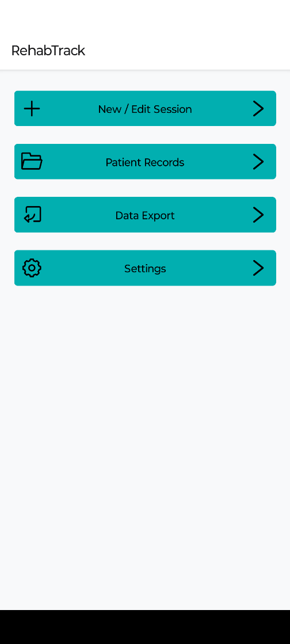

## New Session Screen

The New Session button allows you to create a new session by adding and assigning exercises to patients and saving the results. Follow these steps:

1. Select patients.
2. Select session.
3. Assign exercise routines.
4. Manually record exercise repetitions.
5. Save the data.

Buttons:

* **Select Patient Dropdown**: Select an existing patient from the dropdown menu.
* **Select Session Button**: Once a patient is selected, tap the select session button to select a previously created session or to add a new session.
* **Add Exercise Button**: With a session selected, tap the add exercise button to add an exercise to the exercise list displayed below.
* 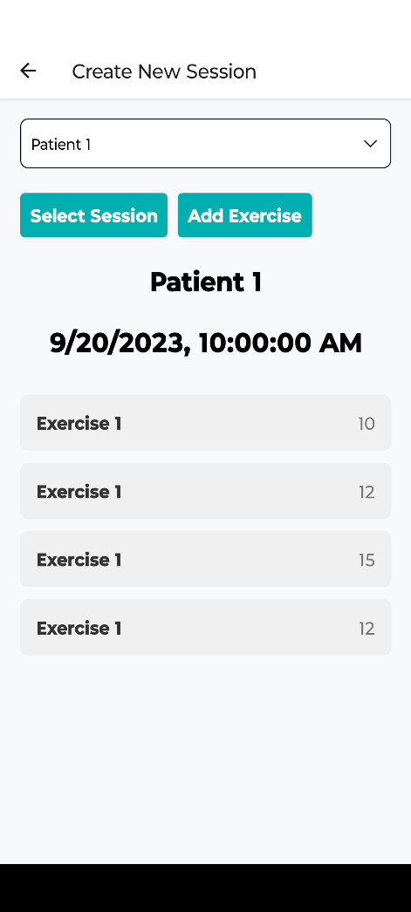**Exercises**: Select an exercise to open the Repetitions Screen to make changes / edit the chosen exercise.

## Repetitions Screen

The Repetitions Screen displays the number of exercise repetitions performed in a specific session. Here, you can add or remove reps, save session data, or discard session data.

Buttons:

* **Exercise Dropdown list: Select an exercise name to assign to currently selected exercise.**
* **Repetitions Number: Select the number of reps to manually type in a value.**
* **+ :** Increase the number of exercise repetitions.
* **- :** Decrease the number of exercise repetitions.
* **Save:** Save session data.
* **Discard:** Edits / changes are discarded, and user returns to the New Session Screen.

## Settings Screen

The Settings Screen offers options for managing app data. Please note that some options are primarily intended for developers and testing purposes.

Buttons:

* **Clear Data:** Use this button to clear any existing data (use with caution – will delete all data, cannot be undone).
* **Dummy Data:** This option allows developers to test app functionality (use with caution – will overwrite all existing data, cannot be undone).
* **Clear Exercise List:** Clears the list of exercises completely. Does not remove exercises from the saved data. This button should only be used if you want to rewrite all exercises in the list. If there are only minor changes you should delete the exercise manually by finding them and using the remove button on each exercise.

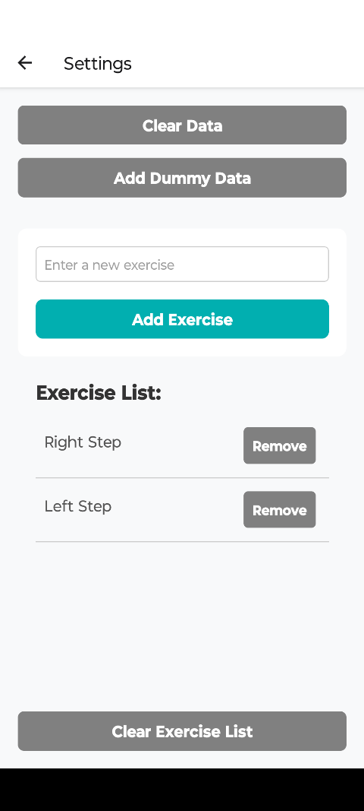

## Patient Records Screen

The Patient Records Screen displays a list of patient records. You can add new patients using the "New Patient" button or search for existing patients.

Buttons:

* **New Patient Button**: Tap to bring up a input box to add a new patient of given name.
* **Select Patient Dropdown**: Open the dropdown list to select a patient or search for one.
* 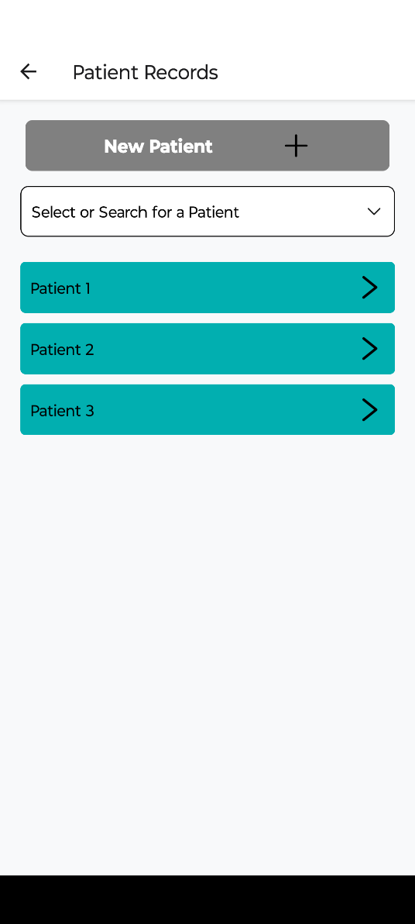**Patient List**: Select a patient from the list of patients displayed below. This will navigate to the patient screen.

## Patient Screen

The Patient Screen provides detailed information for individual patients. Here, you can access session history, view progress graphs, and delete patient data.

Buttons:

* **Session History:** View a list of sessions for the selected patient.
* **Progress Graph:** Visualize the patient's progress through a graph.
* **Delete Patient Data:** Remove the selected patient's data.
* **Return Home Button:** Use this button to return to the Home Screen from any other page within the app.

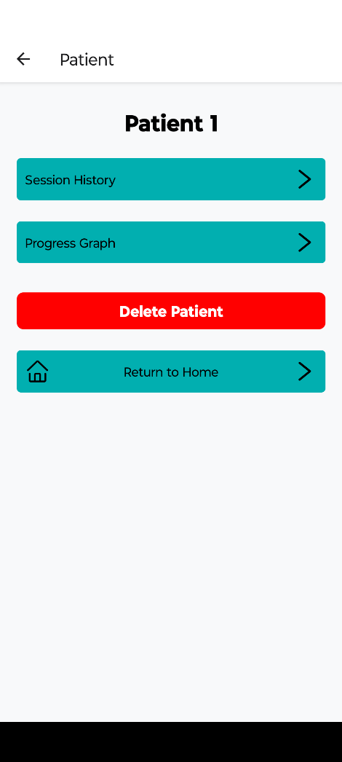

## Session History Screen

The Session History button provides a list of recorded sessions for the selected patient, including the number of exercises the patient did on a specific day. Choose a session to view its details on exercise repetitions on the Session Screen.

Buttons:

* **Session Button: Tap a session to navigate to the session screen and view the exercise data of that session.**
* 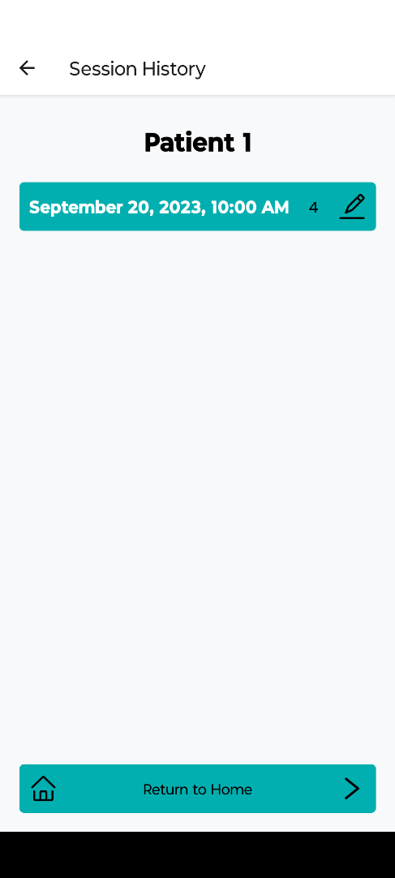**Return Home Button:** Use this button to return to the Home Screen from any other page within the app.

## Session Screen

The Session Screen displays a list of the exercises and the repetitions for each exercise for the specified session. You can delete the session from this screen or return to home from here.

Buttons:

* **Delete Session Button: Delete the current session and return the user to the patient screen.**
* **Return Home Button:** Use this button to return to the Home Screen from any other page within the app.

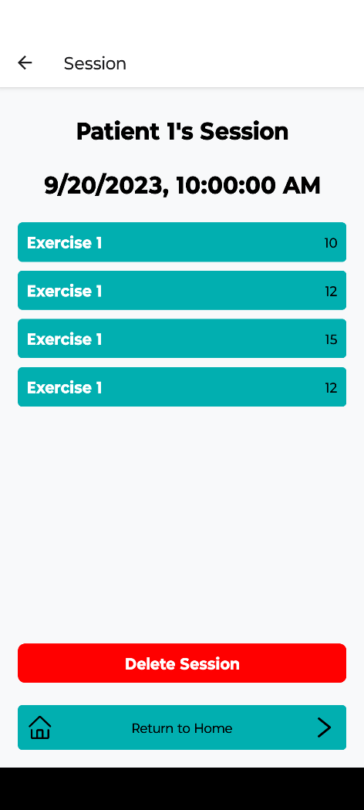

## Data Export Page

The Data Export Page is used to export patient data to a .csv file. You can export all patient data or specify a date range.

Buttons:

* **Export All Data:** Export data for all patients to a .csv file.
* **Export Patient Data:** Choose a specific patient to export their data to a .csv file.
* **Export Range Data:** Select a date range to export patient data within that period.

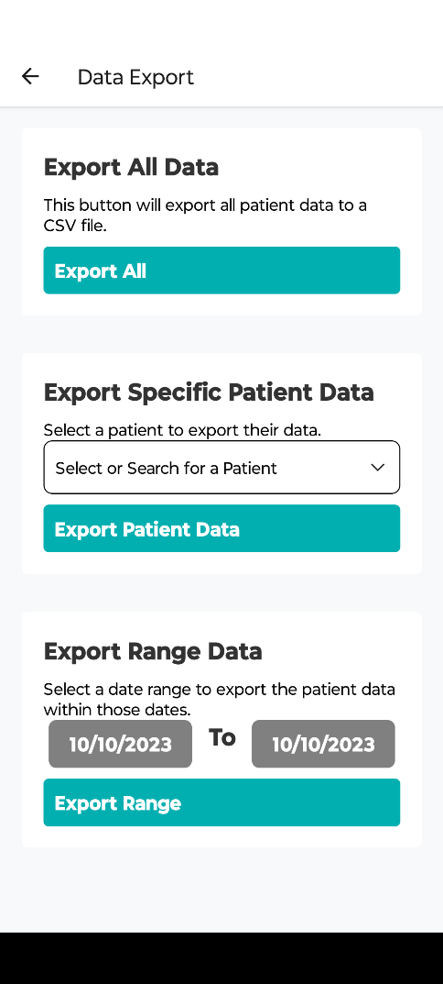

## Graphing Screen

The Graphing Screen displays the exercise history of a patient/ their progress using a graphical representation. Graphs show data from one exercise only, which you can select under ‘Exercise Selection’. You can select sessions by date and return to the Home Page.

Buttons:

* **Date Range:** Select a range of dates to display the selected exercise date that occurred between the two given dates.
* 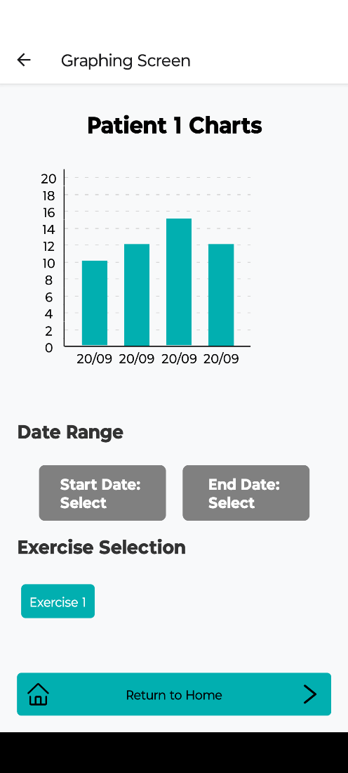**Exercise Selection:** Displays a horizontally scrolling list of exercises. When tapped, this exercise is chosen and displayed to the chart.

